**Scenario: You have submitted a paper to a conference and you have gotten the comments. You need to know the comments about “communication” in your paper, and you want to see what part of paper was mostly.**

**We have made a system that extracts information of articles and allows analysis based on them. We want to compare directly checking the paper reviews and the output of analysis of the extracted information.**

Please do these two tasks then answer the questionnaire.

**TASK** 1.

1. **checkout comments performed by Reviewer2 about “communication” and say that comment was too general?**

1. Using this link <https://afshin.databox.me/public/Article1.html#2987879860>
2. Using the an automatic system that searches the word comment between comments and shows the response shown below this image

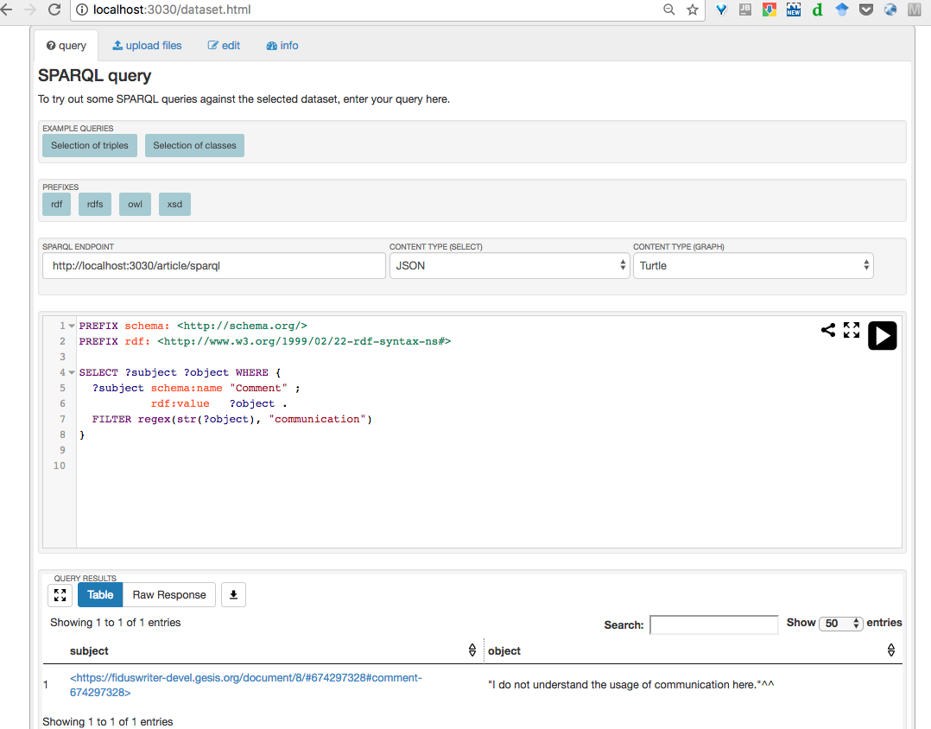

**TASK** 2.

**2. Find out the most commented section in the article.**

1. Using this link <https://afshin.databox.me/public/Article1.html#2987879860>
2. Using the result of the analysis shown below this image

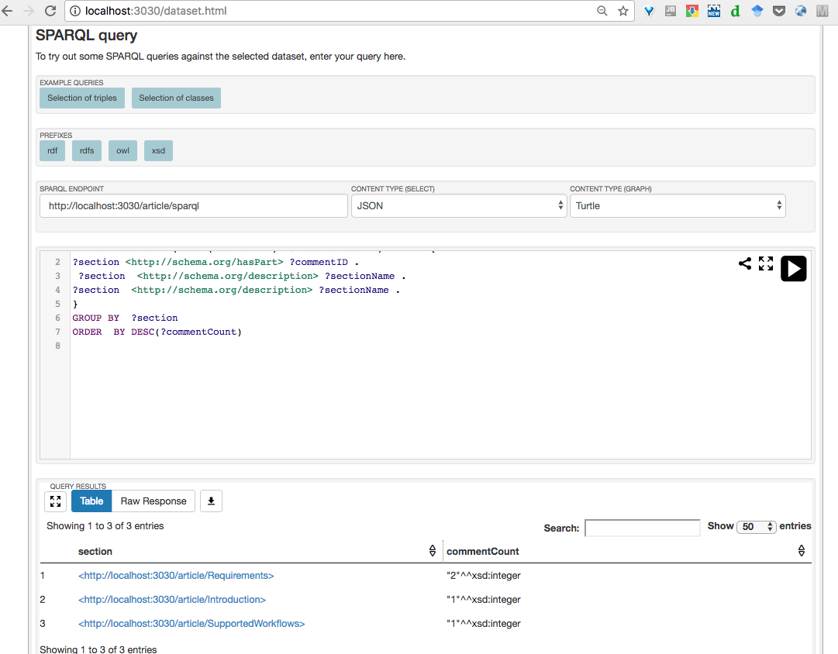

**Overall reaction to the system**

1. Between 1. **terrible** to 9. **Wonderful** what point do you give. 7
2. Between 1. **difficult** to 9. **easy** what point do you give. 7
3. Between 1. **frustrating** to 9. **satisfying** what point do you give. 9
4. Between 1. **Inadequate** **power** to 9. **adequate** **power** what point do you give. 5
5. Between 1. **dull** to 9. **stimulating** what point do you give. 9
6. Between 1. **rigid** to 9. **flexible** what point do you give. 4

**Learning**

1.Have you ever reviewed a paper? no

2. Learning required to do the task? yes

3. Remembering the names and use of commands? It was given

4.Performing tasks is straightforward? Yes it was

5.does it need supplemental reference materials? Some introductory to use it is required

**System Capabilities**

6.System speed? Depending to the task was mach faster

7.System reliability? yes

8.System tends to be? I would wish if it be more flexible , It would be perfect if the system could formulate query and read questions in natural language and user could give his question

9.Correcting your mistakes or do less mistake? It was not possible to do many mistakes

10. Designed for all levels of users? If you don't know sparql at all the first task layout can be very confusing

List of the most Negative aspects?

1. I would wish more flexibility

List of the most Positive aspects?

1. That depending the task it can solve it very fast.